Florida State Board of Education for Religious Studies
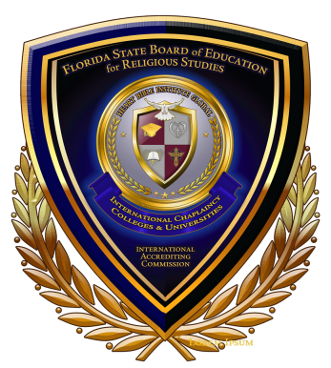
10850 Eureka St, Boca Raton Florida, 33428
Phone(800)737-0984

APPLICATION FOR LICENSE / FEE

INSTITUTION INFO | ID#:
NAME: | DATE:
SUBMITTED BY

GENARAL FEEBASED ON POSSIBLE ENROLLMENT
FIRST: (0-1500)STUDENTS = $500  SECOND : 200 -250 STUDENTS = $1,000  THIRD: 255-1,000 STUDENTS = $1,900 | ABOVE 1,000 STUDENTS FEE IS $2500
DIPLOMA PROGRAM  $1,000 | DEPREE PROGRAM  $2,000

PLEASE SUBMIT THIS FORM TO OUR OFFICE
YOUR CHECK, CASHIER’S CHECK OR MONEY ORDER MADE PAYABLE TO
FLORIDA STATE BOARD OF EDUCATION FOR RELIGIOUS STUDIES
10850 Eureka St, Boca Raton Florida, 33428
Phone(800)737-0984

